Predicting E-Commerce Product Returns and Assessing Their Financial Impact Using Machine Learning and Power BI

Submitted By
Name: Ezhil Mamnose P
Register No.: 2501722037019
- Introduction
The rapid growth of e-commerce has increased the volume of online transactions and consequently the number of product returns. Product returns create additional operational and financial challenges for e-commerce businesses because returned products may require reverse logistics, inspection, repackaging, replacement, refund processing and inventory management. Frequent returns can therefore affect profitability and increase the overall cost associated with order fulfilment.
Data analytics and machine learning can help organizations understand the patterns associated with product returns. By analyzing historical transaction, customer, product and order-related information, it is possible to identify factors associated with returns and develop predictive models that estimate whether a new order is likely to be returned.
This case study uses an e-commerce transaction dataset containing information about orders, products, customers, shipping, payments, returns and financial outcomes. Python is used for data preprocessing, exploratory data analysis and visualization. A Random Forest Classification model is developed to predict whether an order will be returned or not returned. The financial impact of returns is also analyzed to understand the relationship between product returns and business outcomes.
1.1 Scope of the Study
This study focuses on analyzing historical e-commerce transaction data to understand product-return patterns, identify factors associated with returns, predict return status using a Random Forest classification model, and examine the financial impact of returned orders. The study also presents the analytical results using Python visualizations and interactive business intelligence tools.

2. Problem Statement
E-commerce businesses process a large number of customer orders, but a significant proportion of these orders may be returned. Product returns can increase operational expenses, reverse-logistics requirements and financial losses. Understanding which factors are associated with product returns is therefore important for improving decision-making and reducing avoidable return-related costs.
The problem addressed in this case study is to analyze historical e-commerce transaction data, identify patterns and factors associated with product returns, and develop a machine-learning model that predicts whether an order is likely to be returned or not returned. The study also examines the financial impact of returned orders and presents the analytical findings through Python visualizations and business intelligence dashboards.

3. Objectives
- To analyze historical e-commerce transaction data and understand the overall pattern of product returns.
- To identify important factors associated with product returns, including product, order, customer and transaction-related characteristics.
- To perform data preprocessing and exploratory data analysis using Python to identify meaningful patterns and relationships.
- To develop a Random Forest Classification model for predicting whether an order will be returned or not returned.
- To evaluate the performance of the machine-learning model using suitable classification metrics such as accuracy, precision, recall, F1-score and confusion matrix.
- To analyze the financial impact of product returns and communicate the major findings through Python visualizations and business intelligence dashboards.

4. Dataset Description
4.1 Dataset Overview
The dataset used for this case study is named returns_sustainability_dataset.csv. It contains historical e-commerce transaction information covering orders, products, customers, shipping, payment methods, return information and financial and sustainability-related attributes.

Property | Details
Dataset | returns_sustainability_dataset.csv
Number of Records | 5,000
Number of Attributes | 23
Target Variable | Return_Status
Prediction Type | Binary Classification
ML Algorithm | Random Forest Classifier
Date Coverage | January 2022 – September 2025

4.2 Important Attributes

Attribute | Description
Order_ID | Unique identification number for each order
Product_ID | Unique identification number of the product
User_ID | Unique identification number of the customer
Order_Date | Date on which the order was placed
Product_Category | Category of the purchased product
Product_Price | Price of the product
Order_Quantity | Quantity purchased
Discount_Applied | Discount applied to the order
Shipping_Method | Shipping method used for the order
Payment_Method | Payment method used
User_Age | Age of the customer
User_Gender | Gender of the customer
User_Location | Customer's location
Return_Status | Indicates whether the order was returned
Return_Reason | Reason provided for the return
Days_to_Return | Number of days taken before returning
Order_Value | Total value associated with the order
Return_Cost | Cost associated with processing the return
Profit_Loss | Financial impact associated with the order
CO2_Emissions | Estimated carbon emissions
Packaging_Waste | Packaging waste associated with the order
CO2_Saved | Estimated CO₂ savings
Waste_Avoided | Estimated waste avoided
4.3 Target Variable
Target Variable: Return_Status
The machine-learning model predicts: Returned or Not Returned
Therefore, the problem is a: Binary Classification Problem

4.4 Dataset Source
Dataset Source: Kaggle
Dataset Title: E-Commerce Returns: Who Will Send It Back?
Platform: Kaggle
Dataset URL: Kaggle – E-Commerce Returns: Who Will Send It Back?
The dataset was obtained from Kaggle and is related to e-commerce product-return prediction. It contains transaction-level information that can be used to analyze customer, product, order and return-related patterns. The dataset was used in this study for exploratory data analysis, machine-learning-based return-status prediction and financial-impact analysis.

4.5 Dataset Limitations
You can use:
The dataset contains 5,000 transaction records covering a specific period from January 2022 to September 2025. Therefore, the findings may not represent all e-commerce businesses, customer populations or product markets. The dataset represents historical transaction behaviour and may not capture all external factors that influence product returns. In addition, September 2025 contains only partial-month data and should therefore be interpreted carefully when analyzing monthly trends.

5. DATA PREPROCESSING
5.1 Data Preprocessing
Data preprocessing was performed to prepare the e-commerce transaction dataset for exploratory analysis and machine learning. The dataset was inspected for missing values, duplicate records, data types, categorical values, numerical ranges, outliers and potential data leakage.
The original dataset contained 5,000 records and 23 attributes. During preprocessing, the Order_Date attribute was converted into a datetime format and additional date-related features were created for analysis.

5.2 Missing Value Analysis
Missing values were checked using the isnull() function for every attribute.
The analysis identified 0 missing values across all 5,000 records. Therefore, no missing-value imputation or deletion was required.
Result:
- Total records: 5,000
- Total missing values: 0
Interpretation:
The dataset was complete with respect to the available attributes, allowing the analysis to proceed without introducing values through imputation.

5.3 Duplicate Record Analysis
Duplicate records were identified using the duplicated() function.
The analysis found 0 duplicate records.
Interpretation:
Since no duplicate rows were identified, no records were removed during duplicate handling.

5.4 Data Type Conversion and Feature Engineering
The Order_Date attribute was initially stored as a string. It was converted into a datetime format using Pandas.
The following additional date-related features were created:
- Order_Year
- Order_Month
- Order_Month_Name
- Order_Year_Month
These derived attributes were used to examine changes in return behaviour over time.

5.5 Categorical Data Validation
The categorical variables were examined using frequency counts.
The major categories identified were:
- Product Category: Clothing, Electronics, Books, Toys and Home Appliances
- Shipping Method: Next-Day, Standard and Express
- Payment Method: Debit Card, Wallet, Credit Card and COD
- Gender: Female and Male
- Return Status: Returned and Not Returned
The target variable contained:
- Not Returned: 3,550
- Returned: 1,450
Therefore, the overall return rate was:
29%

5.6 Numerical Data Analysis
Descriptive statistics were calculated for the numerical attributes.
Some important observations include:
- Average product price: 1,054.29
- Average order quantity: 3.00
- Average discount applied: 25.01
- Average user age: 41.55
- Average order value: 2,366.996
- Average return cost: 58.00
The numerical variables were examined using count, mean, standard deviation, minimum, quartiles and maximum values.

5.7 Outlier Inspection
Box plots were used to inspect potential outliers in:
- Product Price
- Order Value
- User Age
The purpose of this analysis was to identify unusually high or low observations rather than automatically remove them.
Valid high-value transactions were retained because they may represent genuine e-commerce transactions and could contain useful information for the analysis.
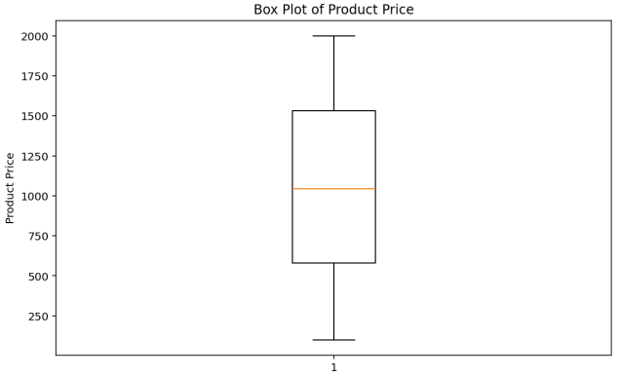

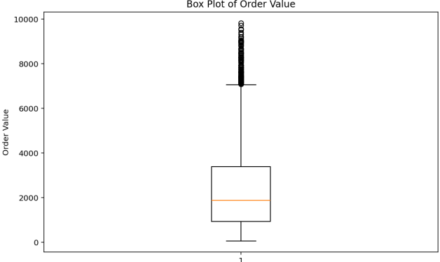

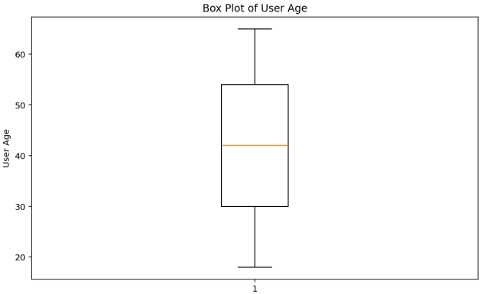

5.8 Feature Selection and Data Leakage Prevention
For the machine-learning stage, features that could reasonably be available at the time of placing an order were selected.
The selected input features are:
- Product Category
- Product Price
- Order Quantity
- Discount Applied
- Shipping Method
- Payment Method
- User Age
- User Gender
- User Location
- Order Value
The target variable is:
Return_Status
The following attributes were excluded from prediction:
- Return_Reason
- Days_to_Return
- Return_Cost
- Profit_Loss
These variables were excluded because they are associated with the return event or may only be known after a return occurs. Including them could introduce data leakage and make the model unsuitable for predicting the return risk of a new order.

5.9 Final Preprocessing Summary
After preprocessing, the dataset contained:
- 5,000 records
- 27 attributes, including the four newly engineered date features
- 0 missing values
- 0 duplicate records
- 10 selected ML input features
- 1 target variable: Return_Status
The processed dataset was then used for exploratory data analysis and preparation for machine-learning modelling.

5.10 Scaling and Normalization
Feature scaling or normalization was not applied because the selected Random Forest classification algorithm is tree-based and does not require numerical features to be standardized. The numerical variables were retained in their original scale after validation.

6. EDA (EXPLORATORY DATA ANALYSIS)
6.1 EDA Overview
Exploratory Data Analysis was performed to understand the distribution of product returns, identify patterns across product categories and time periods, examine the major reasons for returns, and analyze the financial impact associated with returned orders.
The analysis was performed using Python and Pandas. The dataset contains 5,000 e-commerce transaction records, of which 1,450 orders were returned and 3,550 orders were not returned. Therefore, the overall return rate in the dataset was 29%.

6.2 Return Status Distribution
The distribution of orders based on their return status was analyzed to understand the overall proportion of returned and non-returned orders.
- Not Returned: 3,550 orders
- Returned: 1,450 orders
- Overall Return Rate: 29%
Interpretation
The analysis shows that most orders in the dataset were not returned, while 29% of the orders were returned. This indicates that product returns represent a significant portion of the transactions and therefore require further analysis to identify associated patterns and factors.

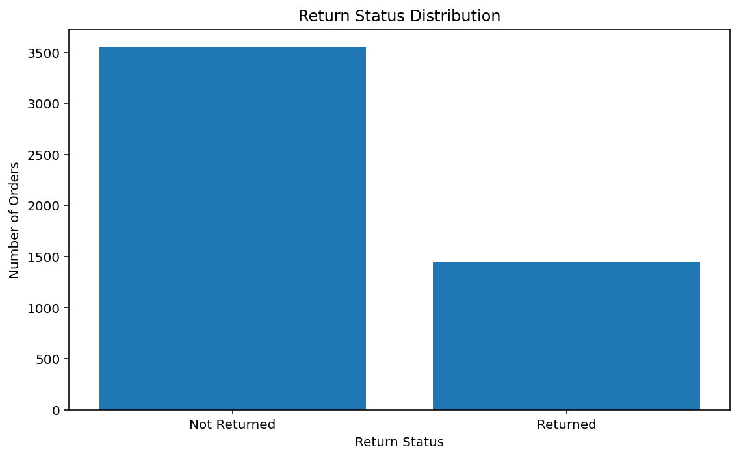

6.3 Return Rate by Product Category
The return rate was calculated separately for each product category to identify differences in return behaviour across categories.
Product Category | Return Rate
Clothing | 37.43%
Home Appliances | 25.63%
Electronics | 25.24%
Toys | 24.07%
Books | 22.57%
Interpretation
Among the product categories, Clothing recorded the highest return rate at 37.43%, while Books recorded the lowest return rate at 22.57%. The results show that return behaviour varies across product categories.

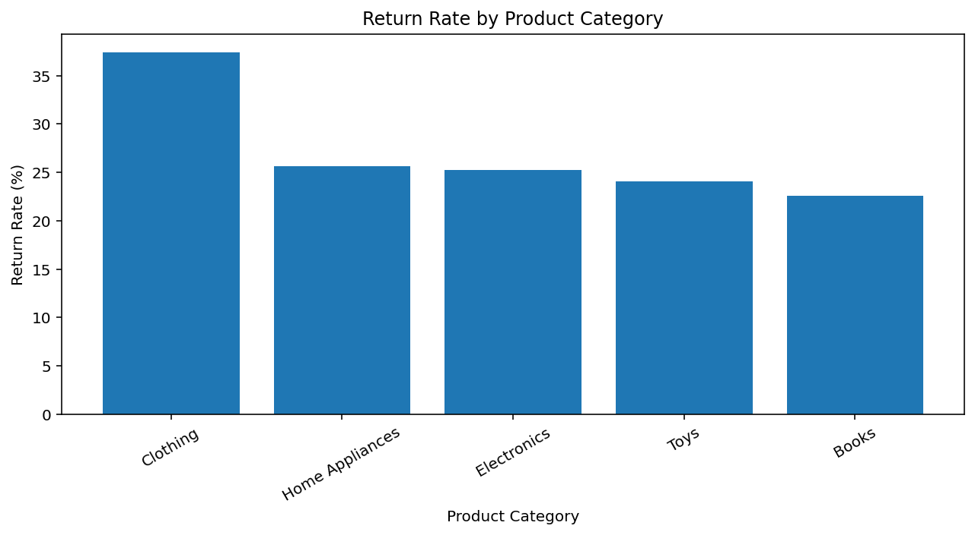

6.4 Monthly Return Rate Trend
The monthly return rate was calculated using the order date to examine how the proportion of returned orders changed over time.
The analysis covered the period from January 2022 to September 2025. The monthly return rate varied throughout the period rather than remaining constant.
Some higher observed monthly return rates included:
- March 2023: 35.90%
- April 2023: 36.36%
- May 2024: 38.18%
- July 2024: 35.25%
- September 2024: 35.87%
- February 2025: 36.73%
- July 2025: 34.68%
September 2025 contains only data through September 3, 2025, so the September 2025 value should not be directly compared with complete months.
Interpretation
The monthly analysis shows variation in return rates across the study period. Several months recorded return rates above 35%, while other months recorded lower values. This indicates that return behaviour changed over time and can be further investigated using temporal and business-related factors.

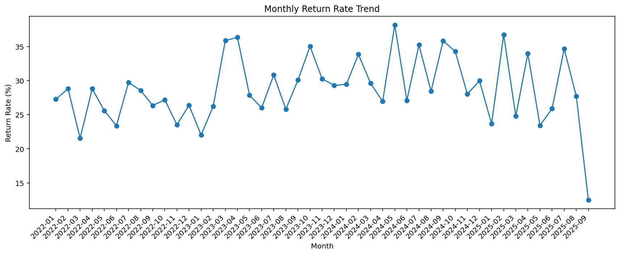

6.5 Return Reasons Distribution
The reasons associated with returned orders were analyzed to identify the major reasons customers returned products.
The recorded return reasons were:

Return Reason | Number of Returned Orders
Defective | 382
Changed Mind | 379
Wrong Item | 348
Size Issue | 341

Interpretation
Among the recorded return reasons, Defective products were the most frequently reported reason, followed closely by Changed Mind. Wrong Item and Size Issue were also significant contributors to product returns.
This analysis helps identify the major categories of return reasons that can be examined further when developing strategies for reducing avoidable returns.

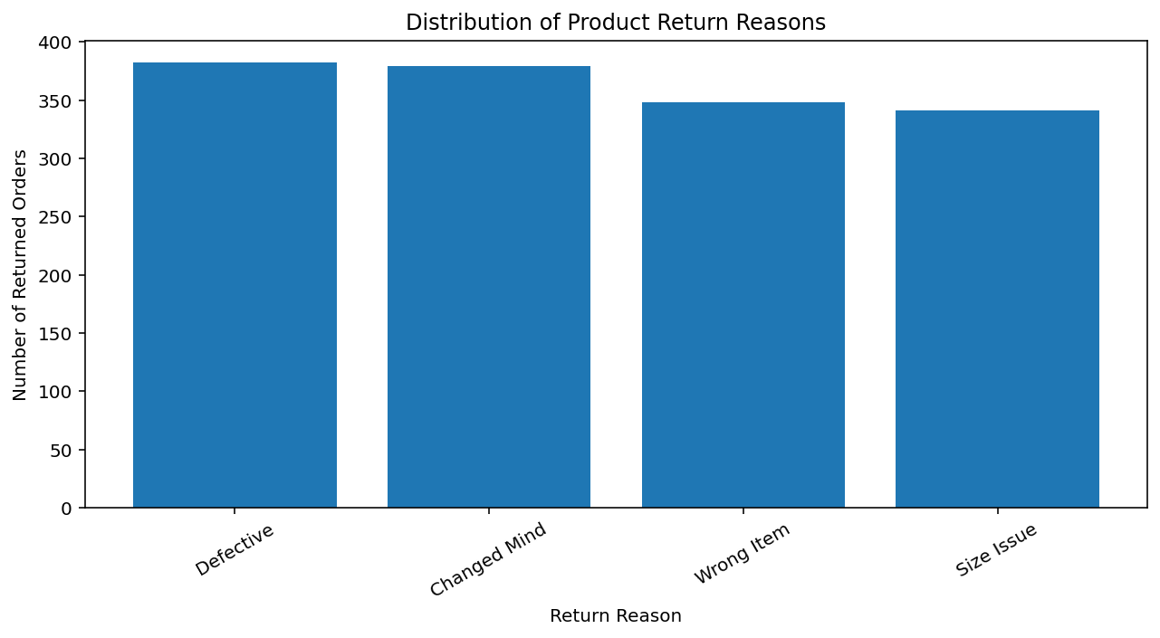
6.6 Financial Impact of Returned Orders
The financial impact of returned orders was analyzed using the Order_Value and Return_Cost attributes for returned transactions.
The analysis produced the following results:
Financial Measure | Amount
Total Returned Order Value | 3,369,391.82
Total Return Cost | 290,000.00
Interpretation
The returned orders represented a total order value of 3,369,391.82, while the associated return cost was 290,000.00. This demonstrates that product returns have a measurable financial impact on the transactions in the dataset.

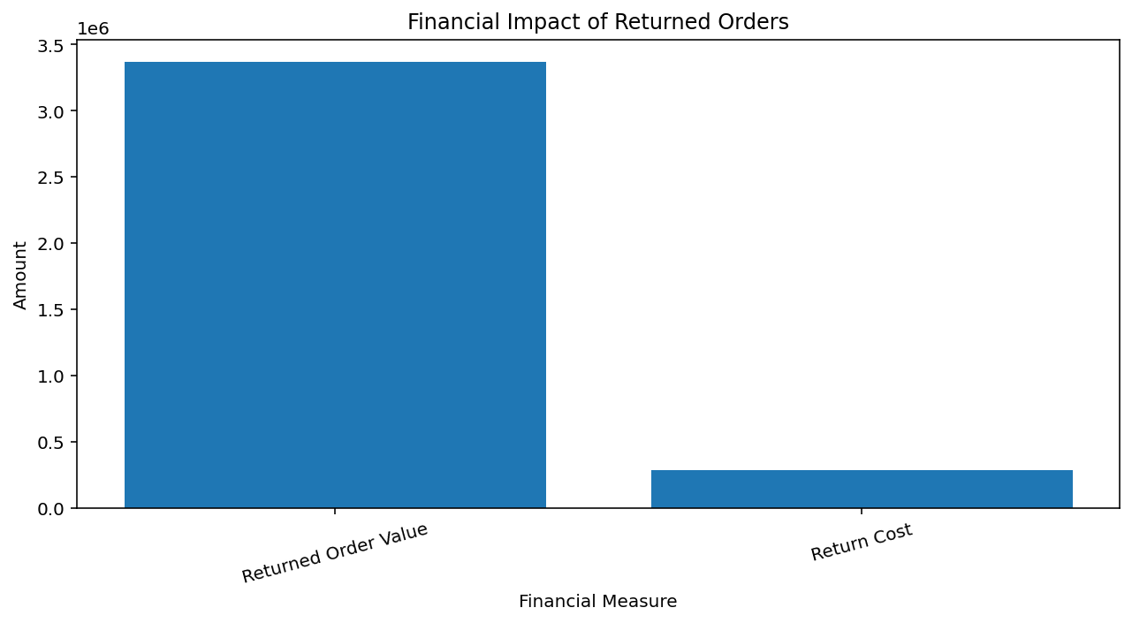

6.7 Key Findings from EDA
The major findings from the exploratory analysis are:
- The dataset contains 5,000 orders, with 1,450 returned orders, resulting in an overall return rate of 29%.
- Clothing recorded the highest category-level return rate at 37.43%.
- Books recorded the lowest category-level return rate at 22.57%.
- Monthly return rates varied considerably across the study period.
- Defective products were the most frequently recorded return reason.
- Returned orders accounted for a total order value of 3,369,391.82.
- The total recorded return cost was 290,000.00.
- The findings provide the basis for the subsequent machine-learning analysis and visualization stages.

6.8 Analytical Questions

Q1. What proportion of orders are returned?

Answer:
Out of 5,000 orders, 1,450 were returned and 3,550 were not returned, giving an overall return rate of 29%.

Q2. Which product category has the highest return rate?

Answer:
Clothing recorded the highest return rate at 37.43%, followed by Home Appliances at 25.63%, Electronics at 25.24%, Toys at 24.07%, and Books at 22.57%.

Q3. How does the return rate change over time?
Answer:
The monthly return rate varies throughout the study period. Several months recorded return rates above 35%, including May 2024 at 38.18%. September 2025 contains only partial-month data and should therefore be interpreted cautiously.

Q4. What are the major reasons for product returns?

Answer:
Defective products were the most frequently recorded return reason with 382 returned orders, followed by Changed Mind with 379, Wrong Item with 348 and Size Issue with 341.

Q5. What is the financial impact associated with returned orders?
Answer:
Returned orders had a combined order value of 3,369,391.82, while the total recorded return cost was 290,000.

7. Machine Learning
7.1 Machine Learning Objective
The objective of the machine learning component is to predict whether an e-commerce order is likely to be Returned or Not Returned based on information available at the time of the order.
The model helps identify patterns associated with product returns and can support early identification of orders with higher return risk.

7.2 Target Variable
The target variable selected for the classification model is:
Return_Status
It contains two classes:
- Returned
- Not Returned
The problem is therefore treated as a binary classification problem.

7.3 Feature Selection
The following features were selected as model inputs:
Feature | Type | Description
Product_Category | Categorical | Category of the purchased product
Product_Price | Numerical | Price of the product
Order_Quantity | Numerical | Number of products ordered
Discount_Applied | Numerical | Discount applied to the order
Shipping_Method | Categorical | Shipping method selected
Payment_Method | Categorical | Payment method used
User_Age | Numerical | Age of the customer
User_Gender | Categorical | Gender of the customer
User_Location | Categorical | Customer location
Order_Value | Numerical | Total value of the order
Features excluded
The following variables were excluded from model training:
- Return_Reason
- Days_to_Return
- Return_Cost
- Profit_Loss
These variables are related to the return event or its financial outcome and may not be available before a return occurs. Including them could introduce data leakage and make the prediction unrealistic.

7.4 Data Preparation for Machine Learning
Categorical variables were converted into numerical form using One-Hot Encoding.
The dataset was divided into:
- 80% Training Data
- 20% Testing Data
A stratified split was used so that the proportion of Returned and Not Returned orders is maintained in both datasets.

7.5 Random Forest Classification
A Random Forest Classifier was selected for predicting the return status.
Random Forest was selected because the problem is a binary classification task and the dataset contains a combination of numerical and categorical variables. After categorical encoding, Random Forest can model non-linear relationships without requiring feature scaling. It also provides feature-importance values, which are useful for identifying the relative contribution of input variables to return-status predictions.
Random Forest is an ensemble machine learning algorithm that combines multiple decision trees to make a final classification. Each tree produces a prediction, and the final result is determined using the combined predictions of the trees.
Advantages for this case study
- Handles both numerical and categorical features after encoding.
- Can model non-linear relationships.
- Does not require feature scaling.
- Provides feature importance information.
- Suitable for classification problems.
The model was trained using the selected order and customer attributes and then tested on previously unseen data.

7.6 Model Evaluation
The model was evaluated using the following metrics:
Accuracy
Accuracy represents the proportion of correctly classified orders among all tested orders.
Precision
Precision indicates how many orders predicted as Returned were actually returned.
Recall
Recall indicates how many of the actual returned orders were correctly identified by the model.
F1-Score
F1-score combines precision and recall into a single measure and is useful when both types of errors are important.
Confusion Matrix
A confusion matrix was used to examine:
- Correctly predicted Returned orders
- Incorrectly predicted Returned orders
- Correctly predicted Not Returned orders
- Incorrectly predicted Not Returned orders

7.7 Model Results
After running the Random Forest model, record the actual results obtained from Python:
Metric | Result
Accuracy | 0.69
Precision | 0.2368
Recall | 0.031
F1-Score | 0.0549

7.8 Confusion Matrix
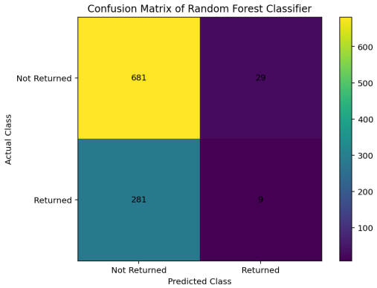
Confusion Matrix of Random Forest Classifier
Interpretation
The confusion matrix shows how accurately the model distinguishes between returned and non-returned orders. It also identifies the number of false predictions made for each class.

7.9 Feature Importance
Random Forest provides feature-importance values that indicate how much each input feature contributed to the model's decision-making process.
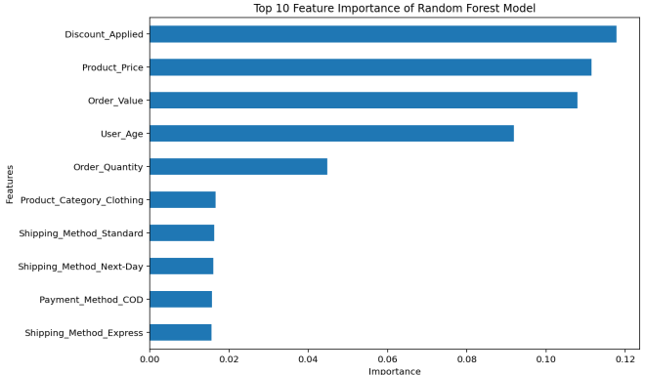
Feature Importance of Random Forest Model
Interpretation
The feature-importance analysis helps identify which customer, order, product, or transaction characteristics contributed most to predicting return status. These results can be used to understand important return-associated factors.

7.10 Machine Learning Summary
The Random Forest classification model was developed to predict whether an e-commerce order would be returned. The model used customer, product, shipping, payment, discount, and order-value information as input variables.
The evaluation metrics and confusion matrix were used to assess prediction performance, while feature importance was used to identify the variables contributing most to the predictions.
The machine learning model complements the exploratory analysis by moving from historical return analysis to prediction of return status for new orders.
8. Python Visualization
8.1 Python Visualization Overview
Python was used to create meaningful visualizations for analyzing e-commerce product returns and their financial impact. The visualizations were selected based on their relevance to the problem statement and the objectives of the case study. The analysis focuses on the overall distribution of returned orders, return rates across product categories, monthly return trends, major return reasons, and the financial impact associated with returned orders.
Five visualizations were created using Python and Matplotlib. Each visualization includes an appropriate title and labels and is followed by an interpretation of the important finding obtained from the analysis.

8.2 Visualization 1 – Return Status Distribution
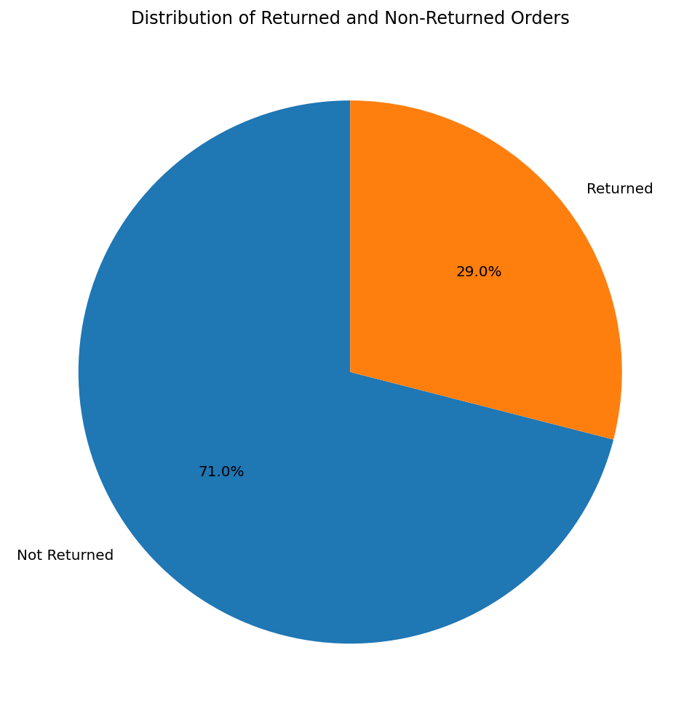
Distribution of Returned and Non-Returned Orders
Interpretation
The visualization shows the distribution of returned and non-returned orders in the dataset. Out of 5,000 total orders, 1,450 orders were returned, while 3,550 orders were not returned. This represents an overall return rate of 29%.
The result indicates that product returns form a significant proportion of the transactions in the dataset. Therefore, understanding the factors associated with returns is important for analyzing the operational and financial impact of e-commerce returns.
8.3 Visualization 2 – Return Rate by Product Category

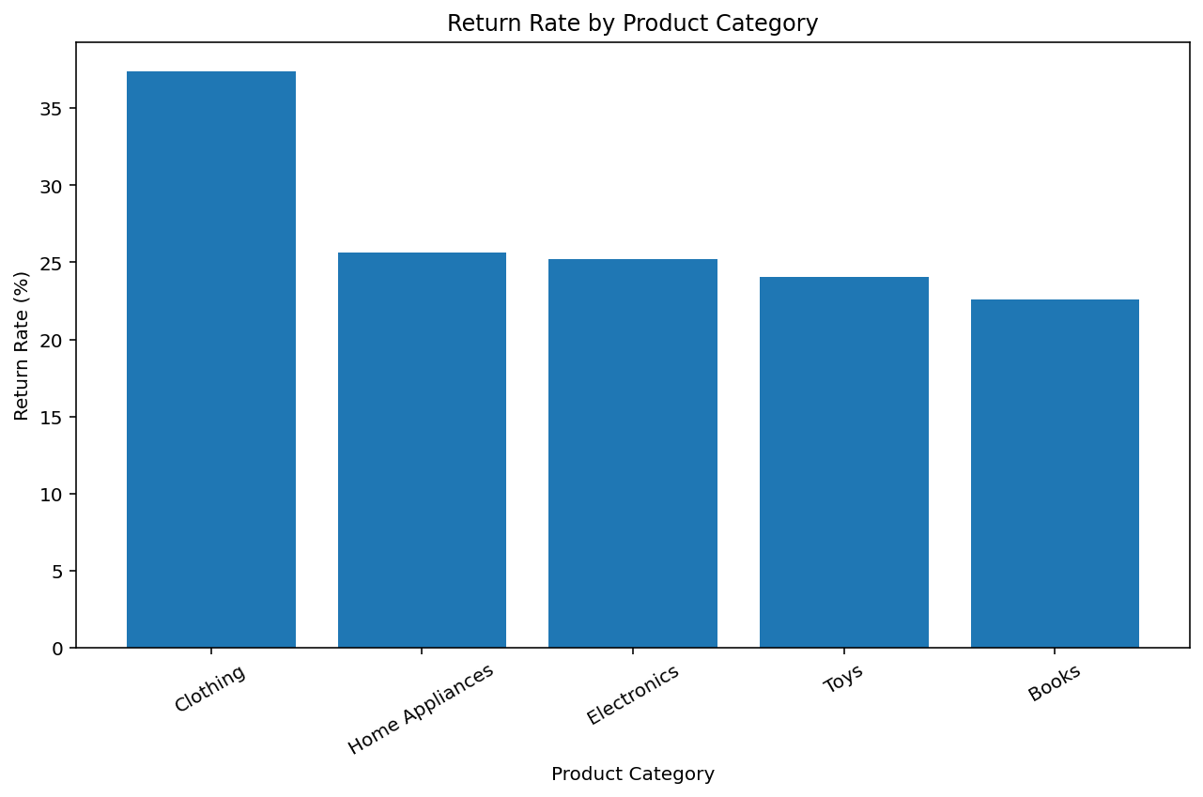

Return Rate by Product Category

Interpretation
The visualization compares the percentage of returned orders across different product categories. Clothing recorded the highest return rate at 37.43%, followed by Home Appliances at 25.63% and Electronics at 25.24%. Toys recorded a return rate of 24.07%, while Books had the lowest return rate at 22.57%.
The difference between categories indicates that return behaviour varies depending on the type of product. Product category can therefore be considered an important factor when analyzing and predicting product returns.

8.4 Visualization 3 – Monthly Return Rate Trend

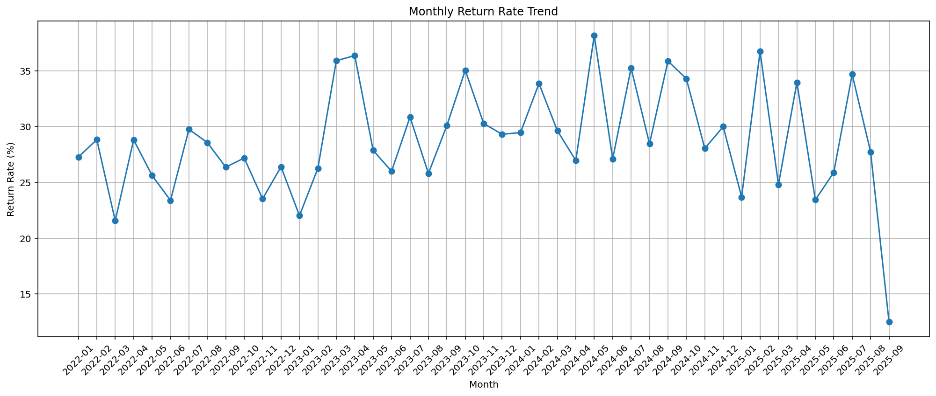

Monthly Return Rate Trend

Interpretation
The line chart presents the monthly return rate throughout the study period. The return rate varies across different months, indicating that returns do not remain constant over time.
Several months recorded return rates above 35%. The highest observed monthly return rate was 38.18% in May 2024. The variation in monthly return rates indicates that time-related patterns may also be relevant when studying e-commerce return behaviour.
The September 2025 value should be interpreted carefully because the dataset contains records only up to September 3, 2025, making it a partial month.

8.5 Visualization 4 – Distribution of Product Return Reasons

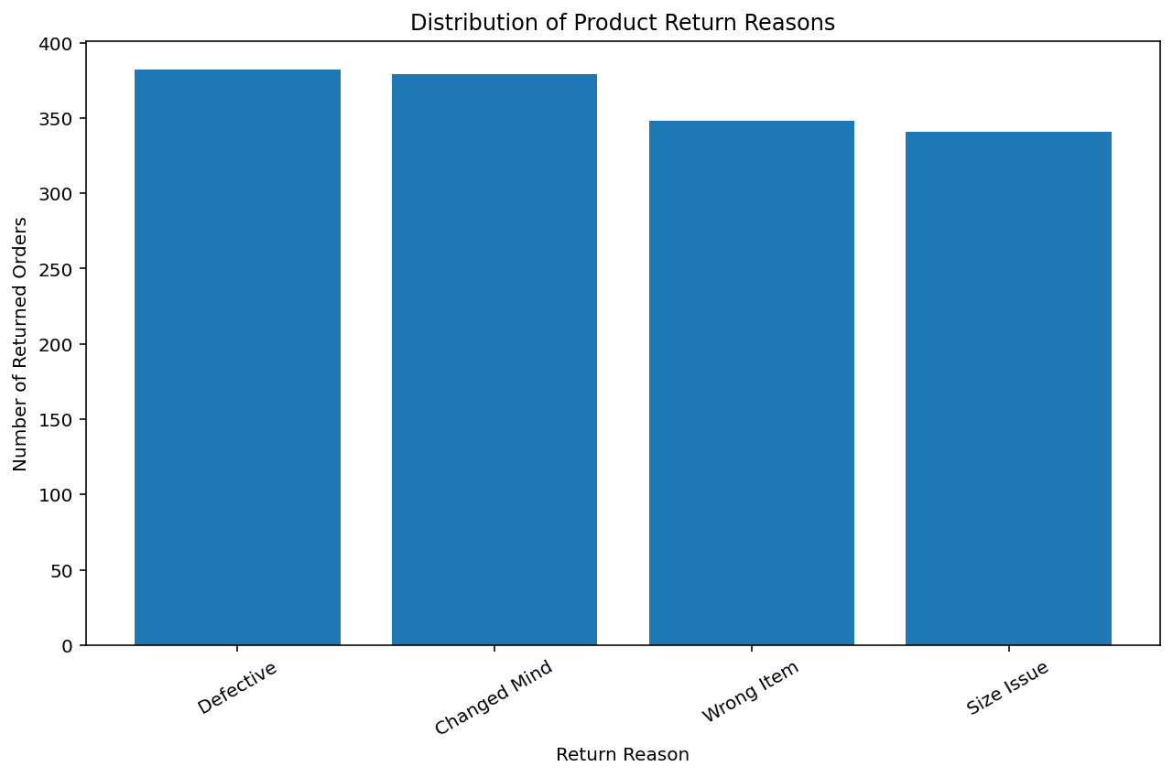

Distribution of Product Return Reasons

Interpretation
The visualization shows the major reasons reported for returned products. Defective products were the most common return reason, with 382 cases, followed by Changed Mind with 379 cases. Wrong Item accounted for 348 cases, while Size Issue accounted for 341 cases.
The results show that returns occur due to both product-related issues and customer decision-related reasons. In particular, the high number of defective-product returns highlights the importance of product quality in reducing return-related problems.

8.6 Visualization 5 – Financial Impact of Returned Orders

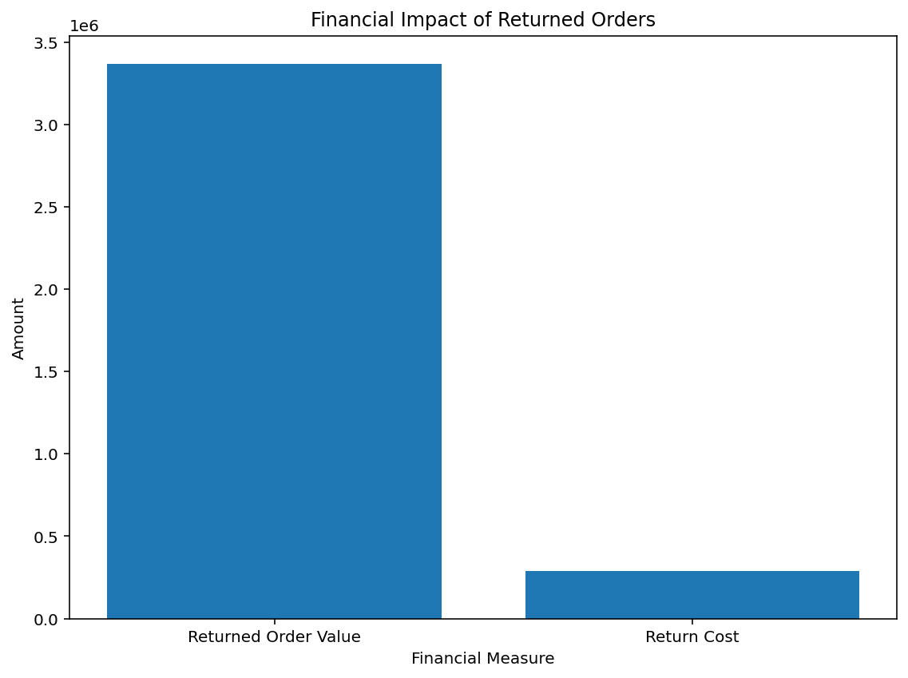

Financial Impact of Returned Orders

Interpretation
The visualization compares the total order value associated with returned orders with the recorded return cost. The returned orders had a combined order value of approximately 3.37 million, while the total recorded return cost was 290,000.
This demonstrates that product returns have a measurable financial impact on e-commerce operations. The analysis therefore supports the need to identify return patterns and factors associated with returns so that businesses can better understand and manage the financial consequences of returned orders.

8.7 Summary of Python Visualization

The Python visualizations provided a graphical analysis of e-commerce product returns and their associated financial impact. The analysis identified an overall return rate of 29%, with 1,450 returned orders out of 5,000 transactions.
Among the product categories, Clothing recorded the highest return rate at 37.43%, indicating considerable variation in return behaviour between categories. The monthly analysis also showed fluctuations in return rates throughout the study period, with May 2024 recording the highest observed monthly return rate of 38.18%.
The analysis of return reasons showed that Defective products and Changed Mind were the two most frequently recorded reasons for returns. In addition, returned orders represented an order value of approximately 3.37 million, with recorded return costs of 290,000.
Overall, the visualizations provide evidence of differences in return behaviour across product categories, time periods and return reasons, while also demonstrating the financial significance of product returns. These findings provide a foundation for the subsequent interactive dashboard analysis and support the overall objectives of the case study.

9: POWER BI DASHBOARD

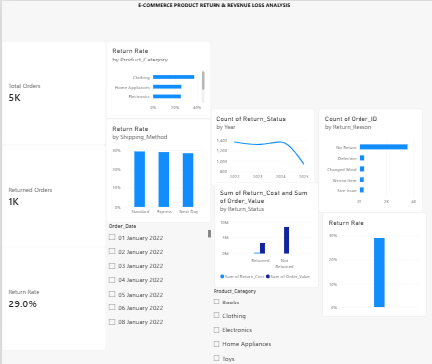

9.1 Introduction
Power BI was used to create an interactive dashboard for analyzing e-commerce product returns. The dashboard presents key performance indicators (KPIs), product return patterns, shipping-related comparisons, return reasons, monthly trends, and the financial impact of product returns. Interactive slicers allow users to explore the data by product category and order date.
9.2 Key Performance Indicators (KPIs)
Three KPI cards were created to summarize the overall performance of the e-commerce dataset.
- Total Orders: Displays the total number of orders in the dataset.
- Returned Orders: Displays the number of orders marked as returned.
- Return Rate: Represents the percentage of returned orders relative to total orders.
These KPIs provide a quick overview of order activity and product returns.

9.3 Power BI Visualizations
9.3.1 Return Rate by Product Category
A horizontal bar chart was created to compare return rates across different product categories. The visualization helps identify categories with relatively high return rates. Clothing recorded the highest return rate in the dataset at approximately 37.43%, indicating that this category requires further investigation.
9.3.2 Return Rate by Shipping Method
A column chart was used to compare return rates among Next-Day, Standard, and Express shipping methods. This visualization helps identify differences in return behaviour across shipping options and supports further investigation into shipping-related factors.
9.3.3 Distribution of Product Return Reasons
A bar chart was created to show the number of orders associated with each return reason. The dataset includes reasons such as defective products, changed minds, wrong items, and size issues. This visualization helps identify common causes of product returns.
9.3.4 Monthly Returned Orders Trend
A line chart was created to examine changes in returned orders over time. The date field was used to organize the data by month. This visualization helps identify changes in return activity and potential periods requiring further investigation.
9.3.5 Order Value and Return Cost by Return Status
A clustered column chart was created to compare order value and return cost across return statuses. This visualization provides a financial perspective on returned and non-returned orders and helps users explore the relationship between order value and return-related costs.

9.4 Interactive Slicers
Two slicers were incorporated into the dashboard to support interactive analysis.
- Product Category Slicer: Allows users to filter the dashboard by categories such as Clothing, Electronics, Books, Toys, and Home Appliances.
- Order Date Slicer: Allows users to examine data for selected dates or date ranges.
These slicers make the dashboard more flexible by allowing users to focus on specific categories and time periods.
9.5 Dashboard Insights
The Power BI dashboard provides the following insights:
- Clothing has the highest return rate among the product categories, at approximately 37.43%.
- Return reasons can be compared to identify common product and fulfilment issues.
- Shipping methods can be evaluated to investigate differences in return rates.
- Monthly analysis helps identify changes in return activity over time.
- Comparing order value and return cost provides a financial perspective on product returns.
9.6 Conclusion
The Power BI dashboard presents e-commerce return data through interactive KPI cards, charts, and slicers. It enables users to explore product return patterns, compare categories and shipping methods, examine return reasons, analyze monthly trends, and investigate financial impacts. The dashboard supports data-driven decision-making by presenting important information in a clear and interactive format.

10: TABLEAU DASHBOARD

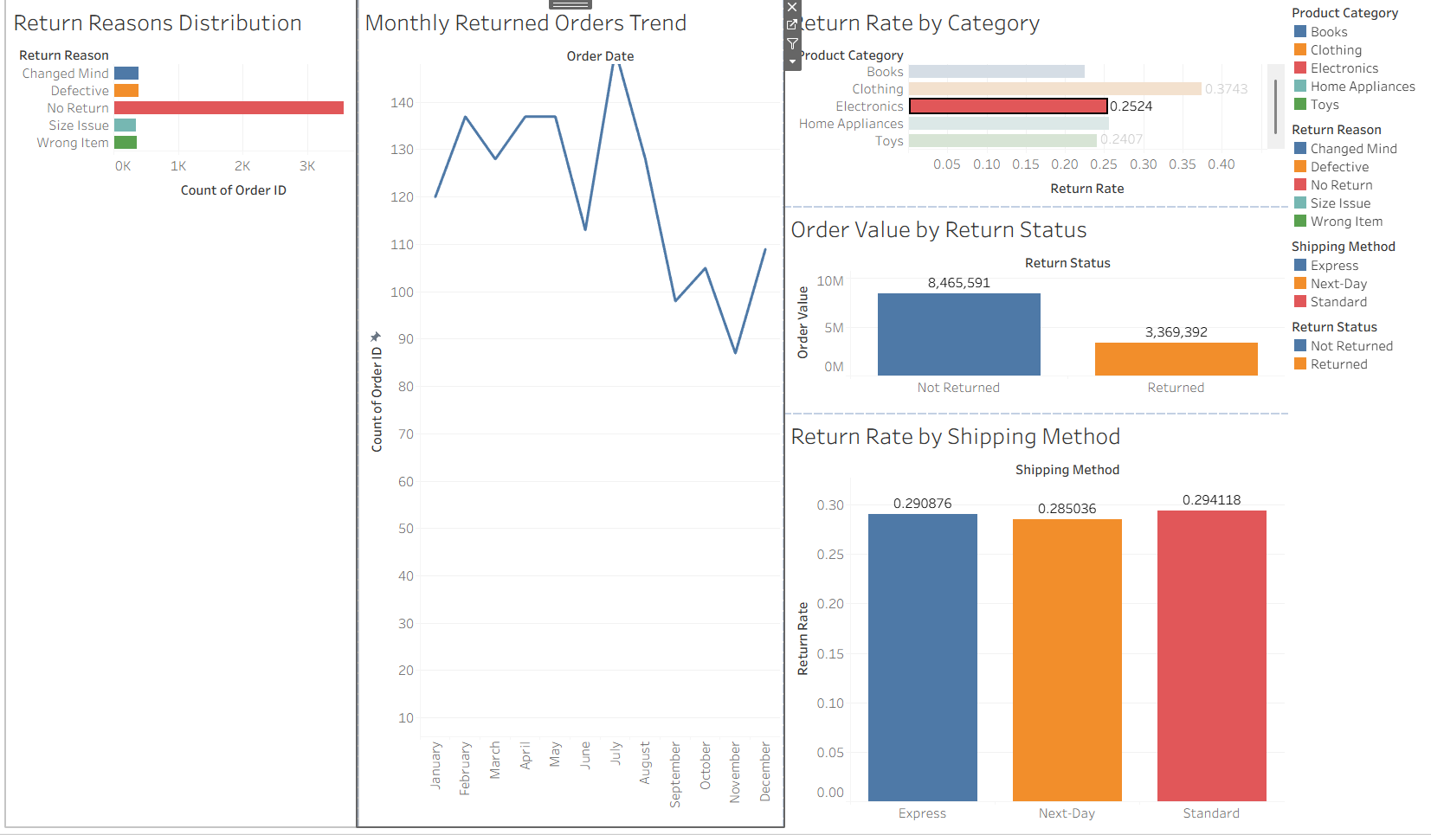

10.1 Introduction
Tableau was used to create visualizations and an interactive dashboard for analyzing e-commerce product returns. The dashboard presents return rates, return reasons, monthly return trends, shipping method comparisons, and order value by return status.
10.2 Tableau Visualizations
10.2.1 Return Rate by Product Category
This chart compares product return rates across different categories. It helps identify categories with higher return rates and areas that require improvement.
10.2.2 Return Reasons Distribution
This chart displays the number of orders associated with different return reasons, such as defective products, wrong items, size issues, and changed minds.
10.2.3 Monthly Returned Orders Trend
This line chart displays changes in returned orders over time. It helps identify trends and periods with increased returns.
10.2.4 Return Rate by Shipping Method
This chart compares return rates across shipping methods and helps examine possible differences in return patterns.
10.2.5 Order Value by Return Status
This chart compares order values for returned and non-returned orders, providing a financial perspective on product returns.
10.3 Interactive Dashboard
The five visualizations were combined into a single dashboard. The interactive filter allows users to select product categories and explore the corresponding results.
10.4 Key Findings
- Clothing has the highest return rate among the product categories.
- Return reasons help identify product quality and order fulfilment issues.
- Shipping method comparisons help explore differences in return rates.
- Monthly trends reveal changes in return activity over time.
- Order value comparisons provide insight into the financial impact of returns.
10.5 Conclusion
The Tableau dashboard presents e-commerce return data in an interactive and visually understandable format. It helps users explore return patterns, compare categories, and identify areas for further investigation.

11: COMPARISON OF TOOLS
11.1 Introduction
Python, Power BI, and Tableau were used to analyze and visualize the e-commerce product return dataset. Each tool provides different features for data analysis, machine learning, and interactive visualization.
11.2 Comparison
Feature | Python | Power BI | Tableau
Main Purpose | Data analysis and machine learning | Interactive dashboards and business reporting | Interactive data visualization
Data Processing | Supports preprocessing and feature engineering | Supports data transformation | Supports data preparation and analysis
Machine Learning | Supports model development and evaluation | Limited built-in ML capabilities | Supports analytical integrations
Visualization | Customizable charts using Matplotlib | Interactive reports and KPI cards | Interactive charts and dashboards
Interactivity | Depends on the application developed | Slicers and filters | Filters and dashboard actions
Main Advantage | Flexible analysis and predictive modeling | Business-friendly reporting | Flexible and visually rich dashboards
11.3 Conclusion
Python was useful for data preprocessing, exploratory analysis, and developing the Random Forest classification model. Power BI provided an interactive dashboard for monitoring return-related KPIs. Tableau helped compare return patterns through interactive visualizations. Together, these tools provided complementary approaches to analyzing e-commerce product returns.

12: CONCLUSION AND FUTURE SCOPE
12.1 Conclusion
The project, “Predicting E-Commerce Product Returns and Assessing Their Financial Impact Using Machine Learning and Power BI,” analyzed product return patterns using Python, Machine Learning, Power BI, and Tableau.
The dataset contained 5,000 e-commerce orders, of which 1,450 orders (29%) were returned. Exploratory Data Analysis identified Clothing as the category with the highest return rate, at approximately 37.43%. The analysis of return reasons also highlighted issues such as defective products, wrong items, and size-related problems.
A Random Forest classification model was developed to predict product returns. Although the model achieved 69% accuracy, its recall was only 3.1%, indicating that it identified very few returned orders. Therefore, further improvements are needed before the model can be used reliably for return prediction.
Python supported data preprocessing, analysis, machine learning, and visualization. Power BI and Tableau provided interactive dashboards to explore return patterns and financial information.
Overall, the project demonstrates how data analytics and visualization can help e-commerce businesses understand product returns and identify opportunities for improvement.
12.2 Future Scope
The project can be improved in the following ways:
- Improve prediction performance: Apply class weighting, hyperparameter tuning, and threshold optimization to improve the identification of returned orders.
- Include additional features: Incorporate customer feedback, product ratings, product descriptions, and delivery performance where available.
- Enhance dashboards: Add more interactive filters, detailed KPIs, and category-level comparisons.
- Analyze return costs: Investigate the financial impact of returns by category, return reason, and time period.
- Develop a prediction application: Integrate the improved machine learning model into an application that helps businesses identify potentially high-risk orders.
12.3 Final Outcome
The project combines descriptive analytics, machine learning, and interactive visualization to study e-commerce product returns. It provides a foundation for further investigation into return prevention, financial impact, and improved business decision-making.
REFERENCES
- Project Source Code and Files: GitHub Repository — E-Commerce Product Return Prediction and Analysis.
- Repository: DAV Case Study – Ezhil Mamnose P

